This folder contains the code for the Road Network Layout Algorithm. It was demonstrated to generate road layout for a small case study area. This folder contains the following stuffs:

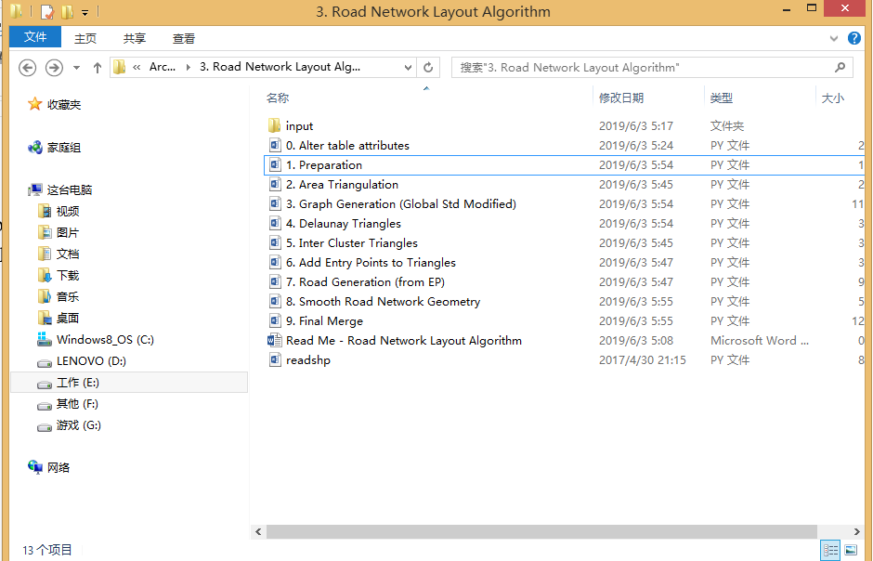

We would need PostGIS to work together with algorithm. The input folder contains the input data of the algorithm and needs to be imported into PostGIS.

**Import data into PostGIS**

To input data, just the approach demonstrated in Generic Algorithm, so basically:

1. Use PgAdmin to for easy import.
2. Name of the table (to store each shapefile) needs to be lower cased, which should be buildings, boundary, and entry_points.
3. SRID is 27700.
4. Do not tick the box of “Generate simple geometries instead of MULTI geometries” in the import options.

**Run the Algorithm**

Sequentially run the script from 0. Attributes.py to 9. Final Merge.py, that means you would need to run 10 scripts totally. If nothing wrong occurs, there will be a folder called /result generated. result/simu_roads_final.shp is the result for the synthetic road layout.

Please note you in each of the 10 scripts, you would still need to set up some parameters, but basically they should be just your PostGIS database name and the password.

For example, the following picture shows the parameters to set up in the file 0. Attributes.py. My database name is “roadtest”, you might want to change it.

